E-Mail attributes;

Subject line should be very informative and personal to what you were doing;

“While you were watching ‘Horizon: Mission to Mars’ you saved these sparks of curiosity”

(Body of E-mail;)

“While you were watching ‘Horizon: Mission to Mars’ (Wednesday 9pm BBC2) you saved these sparks to your binder.”

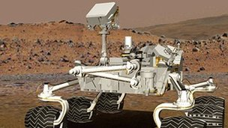

### Science lab on wheels

### What sets Curiosity apart from other Mars Rovers?

### Mission to Mars

What dangers would you face on a journey to the Red Planet?



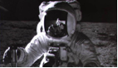

### What did Apollo achieve?

### Was the space programme a great achievement or a waste of money?

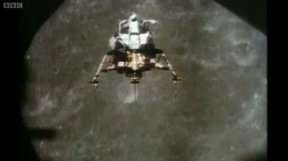

### ‘The Eagle has landed’

### Why was it so difficult to land Apollo 11 on the Moon?

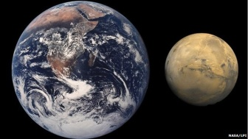

### What makes Mars so hostile?

### If life flourishes on Earth, why does the Red Planet seem so lifeless?